Project Design Phase-II
Data Flow Diagram & User Stories

Date | 21-10-2026
Team ID | Urvashi Malviya
Project Name | Staff Sync - Human Resource Management System
Maximum Marks | 4 Marks

Data Flow Diagrams:
A DFD shows how data moves between users, processes, and the database in the StaffSync HRM system.

Level 0: Context Diagram
HR Administrator
Employee, attendance and leave data
StaffSync HRM System
Reports and status updates
Employee

Level 1: DFD
HR Administrator / Employee
1.0 User Authentication
2.0 Employee Management
3.0 Attendance & Leave Management
D1: MongoDB Database
User, employee, attendance and leave records
Brief explanation: Employees and HR administrators enter data into StaffSync. The system authenticates users, manages employee information, processes attendance and leave requests, and stores records in MongoDB.

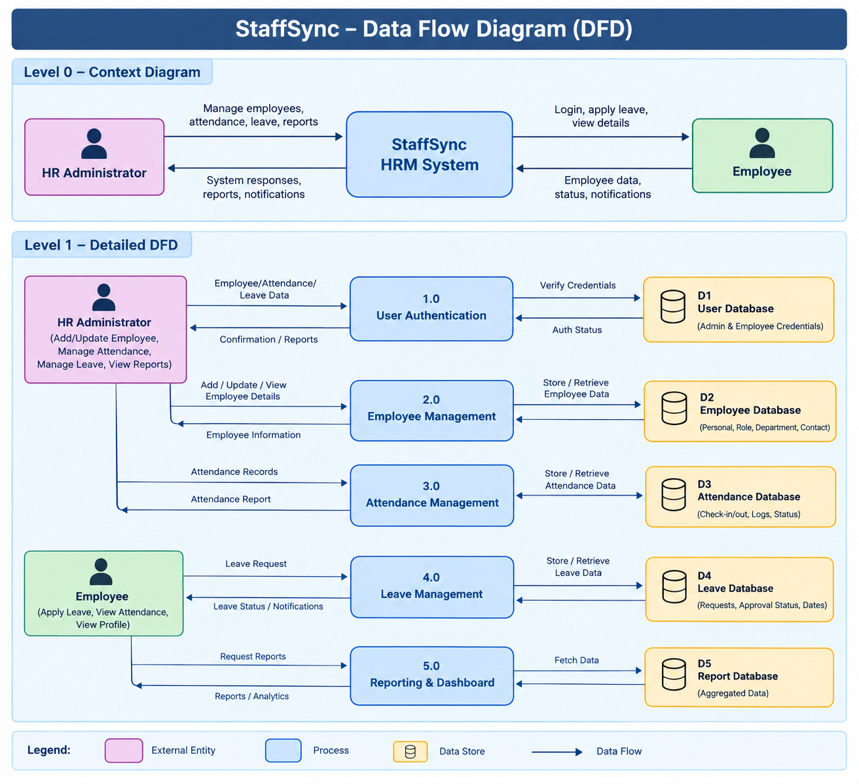

User Stories
User stories describe the features of StaffSync from the perspective of employees and HR administrators.
Format: As a user, I want a feature so that I can achieve a benefit.
ID | User Story | Priority
US-01 | As an employee, I want to log in securely so that I can access my account. | High
US-02 | As an HR administrator, I want to add, update, and view employee details so that employee records remain accurate. | High
US-03 | As an employee, I want to view my attendance so that I can track my working days. | High
US-04 | As an employee, I want to apply for leave online so that I can request time off easily. | High
US-05 | As an HR administrator, I want to approve or reject leave requests so that I can manage employee absences. | High
US-06 | As an HR administrator, I want to manage attendance records so that employee attendance remains organized. | Medium
US-07 | As an HR administrator, I want to view reports and dashboards so that I can monitor HR activities. | Medium
US-08 | As a user, I want to log out securely so that my account remains protected. | High

Acceptance Criteria (Examples)
- Login: The system should validate credentials and allow access only to authorized users.
- Leave management: Employees should be able to submit leave requests and view their status
- Employee management: HR administrators should be able to create, view, and update employee records.

